Chapter 5, Problem 73

Determine the load voltage v_{L} in the circuit of Fig. 5.99.
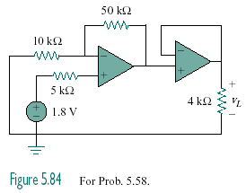

Figure 5.99
For Prob. 5.73.

